UNITED NATIONS  ألأمم المتحدة
United Nations Mission in South Sudan (UNMISS)

Human Rights Division (HRD)

Yambio Field Office Daily Report

19/11/2025
Highlights

- HRD and CAD engaged with the Minister of Local Government and Law Enforcement to follow up on the security situation in Yambio;
- Armed elements loyal to Angelo Davido reportedly attacked SPLA-IO elements in Bangaru village, Nabanga boma, Tambura Central Payam;
- Suspected elements of National Salvation Front (NAS) and SPLA-IO destroyed bridges in Amadi Payam, Mundri West County and Nanewa Boma, Wandi Payam, Mundri East County;
- SSPDF allegedly gang raped a 16-year-old girl in Lakamadi Payam, Mundri East County;
- HRD concludes day two of a four-day capacity building on Human Rights and Governance for traditional leaders in Yambio;
- Political and Security Updates

- HRD and CAD engaged with the Minister of Local Government and Law Enforcement to follow up on the security situation in Yambio;
On 19 November, HRD, together with CAD, met with the Minister of Local Government and Law Enforcement to discuss the prevailing security situation in the state and to get updates on measures taken by the Western Equatoria State (WES) Government to address ongoing tensions between the NSS Operational Forces and SSPDF Mobile II, specifically in light of recent clashes which have significantly impacted the security and human rights situation in the state. The Minister shared that since the WES Governor arrived in the state on 16 November, several security meetings have been convened to address the challenges. He noted that the Governor had instructed the NSS Operational Forces to remain at their compound and to halt night patrols. He added that the Governor directed that subsequent night patrols be conducted by the regional forces and SSPDF commandos. The Minister further confirmed that Brigadier General James Nando was not under arrest. HRD also independently corroborated this information through multiple reliable sources.
- Armed elements loyal to Angelo Davido reportedly attacked SPLA-IO elements in Bangaru village, Nabanga boma, Tambura Central Payam;
On 19 November, according to multiple independent sources, in the morning of the same day, armed elements loyal to Angelo Davido attacked SPLA-IO elements in Bangaru village, Nabanga boma, Tambura Central Payam, Tambura County. According to sources, the armed elements loyal to Angelo Davido, who until recently were affiliated with SPLA-IO, attacked SPLA-IO elements in an attempt to expel them from the boma. Reportedly, the SPLA-IO elements sought to get their support to fight the SSPDF, but they refused. HRD gathered that these armed elements operate under the command of Angelo Davido and, while they are not targeted by the SSPDF, they are also not allied with them. At the time of reporting, HRD is unable to verify the number of casualties; however, sources have indicated that there were casualties from the attack.
Comments: The situation is quite complex and requires further follow-up. At this moment, the breakaway from loyalty to the SPLA-IO in Tambura and the lack of alliance with the SSPDF, if confirmed true, pose significant unanswered questions. If these armed elements are not being targeted by the SSPDF, their motive for maintaining an autonomous armed status, especially given accounts from multiple sources that they attacked SPLA-IO forces, is unclear and concerning. This autonomy suggests a pursuit of control or protection of specific interests that may not align with broader political or SSPDF agendas. This ambiguity increases the potential risk to civilians caught in between.

- Human Rights in the Electoral Process
- Conflict-Related Violations/Abuses

- Suspected elements of National Salvation Front (NAS) and SPLA-IO destroyed bridges in Amadi Payam, Mundri West County and Nanewa Boma, Wandi Payam, Mundri East County;

On 19 November, multiple secondary sources reported that between 13 and 16 November armed elements suspected to be elements of a coalition of NAS and SPLA-IO forces destroyed two bridges: one connecting Amadi Payam and Mundri West County in Mundri West County, and another located in Nanewa Boma, Wandi Payam, Mundri East County. Reportedly, the destruction of these critical civilian infrastructures has had a severe negative impact on the livelihoods of local populations, as it has restricted their ability to freely cross the rivers to access essential goods and services, including healthcare and food supplies. According to sources, the armed elements destroyed the bridges to prevent SSPDF from pursuing them using armored vehicles.

- Conflict-4. Related Sexual Violence (CRSV)

- SSPDF allegedly gang raped a 16-year-old girl in Lakamadi Payam, Mundri East County;

On 19 November, multiple secondary sources, including medical personnel, police, and CSO, reported that on 11 November, 10 soldiers of the SSPDF gang raped a 16-year-old girl from the Moru community in Lakamadi Payam, Mundri East County. Reportedly, the survivor was on her family farm when the SSPDF personnel, who were reportedly in pursuit of SPLA-IO/ NAS elements in the area, arrested and gang raped her. Reportedly, she was evacuated to Lui Hospital in Mundri East County, where she received medical assistance and was discharged 3 days later.

- Sexual and Gender-Based Violence (SGBV)
- Civic Space and Participation
- Judicial Accountability
- Transitional Justice
- Engagements and Capacity Building

- HRD concludes day two of a four-day capacity building on Human Rights and Governance for traditional leaders in Yambio;
On 19 November, HRD, in collaboration with Hold a Child, a national human rights NGO, conducted day two of a four-day capacity-building training on human rights and governance for traditional leaders of the Azande Kingdom and other ethnic communities residing in Yambio. The objective of the training is to strengthen participants' understanding of human rights principles, international human rights law, and their application within the legal framework of South Sudan.
On day two, participants covered the International Bill of Human Rights, the International Covenant on Economic, Social and Cultural Rights, and human rights provisions in South Sudanese law, including Chapter Five of the Revitalized Agreement on the Resolution of the Conflict in the Republic of South Sudan. They also discussed institutions such as the Commission for Truth, Reconciliation and Healing (CTRH), the Hybrid Court for South Sudan (HCSS), the Compensation and Reparation Authority (CRA), and the Convention on the Rights of the Child.
Furthermore, the participants engaged actively in Q&A sessions and practical case-based group discussions focused on issues affecting children in the State. During these discussions, participants expressed disappointment with the government's failure to promptly implement Chapter Five of the peace agreement, noting that delays have led to further human rights violations due to a lack of accountability, allowing perpetrators to act with impunity. They also cited ongoing abductions and violent attacks on civilians and civilian objects in the state as deeply worrying trends.
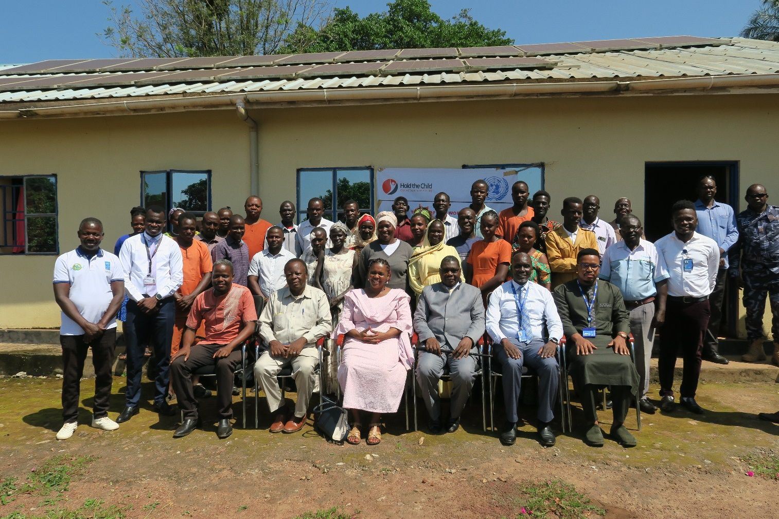
Opening day of the training with the Executive Governor of WES and the Minister of Local Government and Law Enforcement

- Other Key Human Rights and Protection Concerns

SSPDF Commandos are reportedly SSPDF soldiers who were initially deployed to Nzara County, approximately 22km from Yambio town, to combat the Lord's Resistance Army (LRA).

